How to automate Patching with SCCM

Patching is a pain in the a, I mean, neck. SCCM has improved it somewhat but it still requires human intervention. I have finally worked out how to completely automate my patching, And it even scales.

Set up SCCM with a Software Update Point.

* This will require WSUS installed in your environment.
* Configure SUP to synchronize with WSUS on a schedule of your choosing.
  + 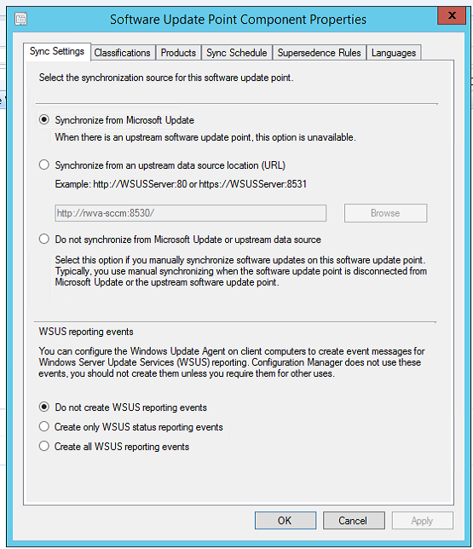
  + Since we wanted to patch weekly, we chose to sync once every Wednesday.
    - 